**Proponents:**

John Mark C. Abril

Farrah Mae Gregorio

**Thesis Proposal**

**MANAGEMENT SYSTEM FOR FOOD E-COMMERCE WITH PAYPAL INTEGRATION AND DATABASE ALGORITHMS**

1. **BACKGROUND OF THE STUDY**

The Management System for Food E-Commerce is one of the latest servicers fastest food restaurants in the western world are adopting. With this method, food is ordered online and delivered to the customer. This is made possible through the use of electronic payment system. Customer through cash. So, the system designed in this project will enable customers go online and pay through credit card or cash and place order for their food.

Due to the great increase in the awareness of internet and the technologies associated with it, several opportunities re coming up on the web. So many business and companies now venture into their business with ease because of the internet. One of such business that the internet introduced is a Management System for Food E-Commerce. In today’s age of fast food and take out, many restaurants have chosen to focus on quick preparation and speedy delivery of orders rather than offering a rich dining experience.

That’s why we proposed Management System for Food E-Commerce with PayPal integration and database algorithms, because we knew having a credit card payment is less time and less bother to the customer. And we include some database algorithms for more security of our database for securing the customer and clients personal information, transaction and even bank accounts. Also included the search algorithms to became more efficient and to optimize the time of searching and loading of the web page. There are 3 users: Administrator for the distributing, monitoring the reports and transaction and etc., Customers for the ordering, transaction, contacting the developers. Agent for the updating the product if they have new product all monitor the product and the order of the customer.

1. **STATEMENT OF THE PROBLEM**

The purpose of this study is to develop a management system for food e-commerce with PayPal integration and database algorithms that helps the user to control the site they provided or created. The main problem of the other online food ordering website they don’t have any payment online, geographical location of the customer, less security provision and the accurateness of the product management.

Specifically, the researcher’s determined questions for this purpose were the following:

1. How the researchers or proponents will have a file management system that can handle the uploaded files or documents of the user?
2. How the management system for food e-commerce with PayPal integration and database algorithms can maintain and secure the files, product and transaction of the client?
3. What are the helps of having a different modules of management system for food e-commerce with PayPal integration and database algorithms performing to improve the website?
4. How the client sure if the management system for food e-commerce with PayPal integration and database algorithms is very secure and safe for money transaction to those unethical hackers?
5. What is the performance of the system according to:
6. Accuracy,
7. Productivity,
8. Security?
9. **CONCEPTUAL FRAMEWORK**

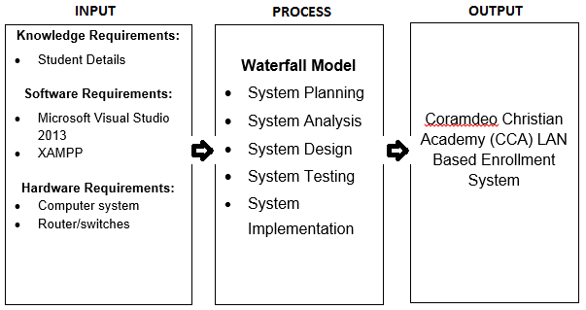This study aims to develop a management system for food e-commerce with PayPal integration and database algorithms with a mobile-friendly design, different modules and application programming interface (API), and the complexity of the entire proposed system. The diagram below presents how this project will be developed.

Management system for food e-commerce with PayPal integration and database algorithms

**Waterfall Model**

* System Planning
* System Analysis
* System Design
* System Testing
* System Implementation

**Knowledge Requirements:**

* Client information
* Client templates design

**Software Requirements:**

* Google Chrome 51.0.2704.103 or any web browsers
* XAMPP
* Operating System – Windows 7 or higher

**Hardware Requirements:**

* A Laptop or Desktop
  + System Requirements
* 1.6 GHz or faster processor
* 2 GB RAM
* 4 GB of available hard disk space
* 5400 RPM hard disk drive
* DirectX 9 capable video card
* 1024 x 768 or higher display resolution
* Internet Connection